Tyler Nichols

CST-307

September 7, 2018

Dr. Citro

My experience with my installation of QtSPIM went very smoothly. After following the on-screen prompts and accepting the installation, it downloaded on my computer and booted it up and copied the code from class and ran it perfectly. Writing in assembler code is very awkward and weird but recently I began writing all my code in C++ and then translating it to assembler in the next line to get a better understanding of the assembler language code and how to properly apply it in a better context. I completed the test programs without too much difficulting but one of the test programs was quite difficult. The program that required a loop to constantly output the number that the user inputted was quite difficult because I could not use the standard syntax logic for C++ because the assembler code syntax worked in a slightly different way. I had to wait until the professor showed the example in class of what happened and how to get it to run properly and after that I then understood what I was doing wrong and how to fix it.

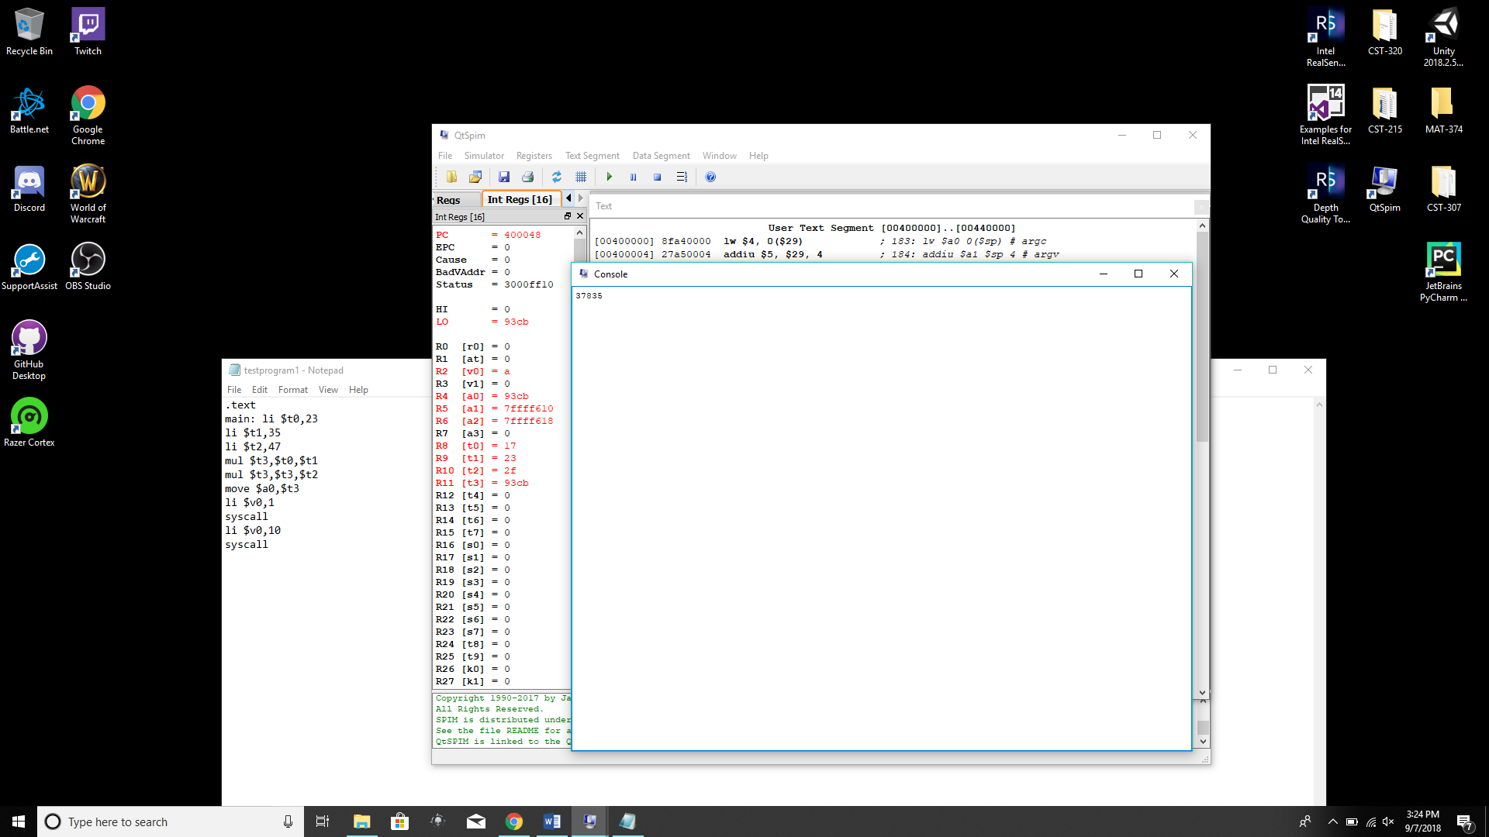

.text

main: li $t0,23

li $t1,35

li $t2,47

mul $t3,$t0,$t1

mul $t3,$t3,$t2

move $a0,$t3

li $v0,1

syscall

li $v0,10

syscall

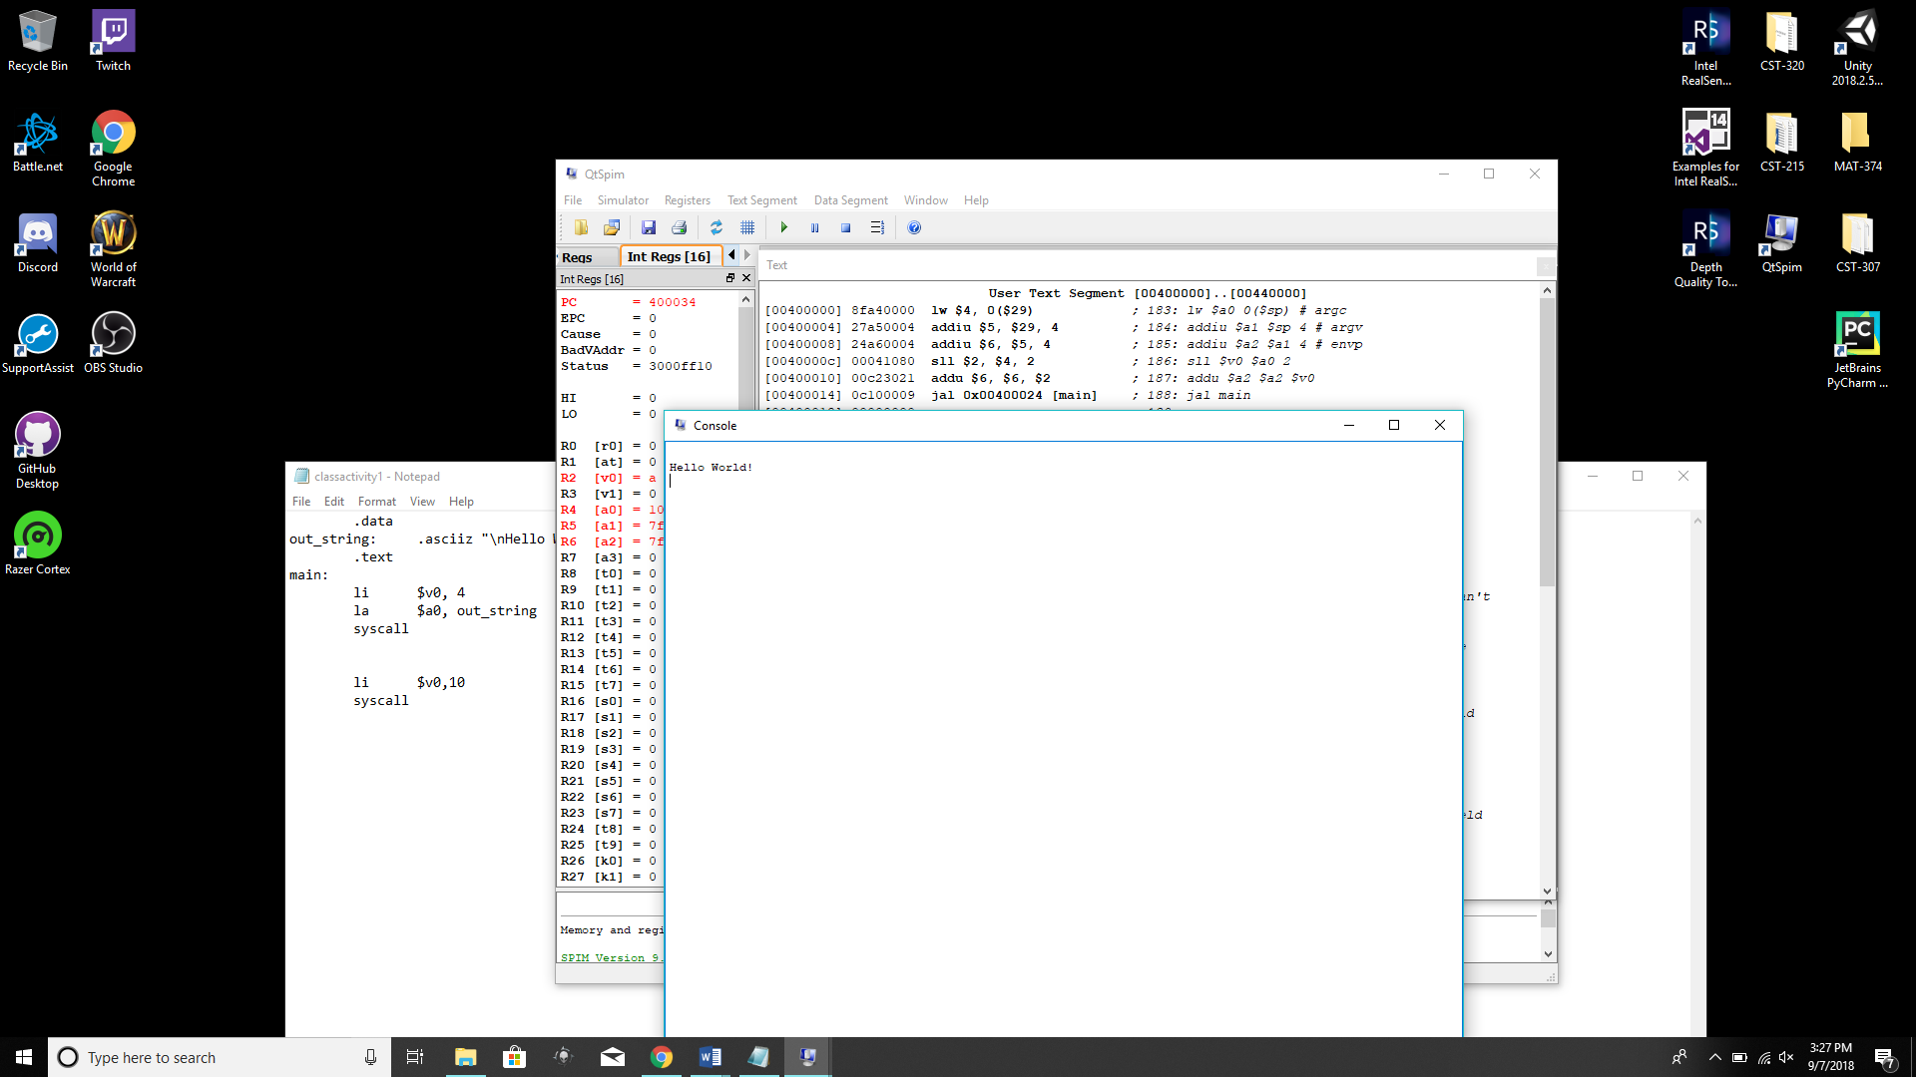

.text

main: li $t2,25

value: .word 12

sw $t3, value

add $t4,$t2,$t3

sub $t3,$t2,$t5

Z: .word 0

sw $t5, Z

li $v0,1

syscall

li $v0,10

syscall